Exp No : 17
UART INTERFACING USING INTERRUPT IN KEIL
AIM : To receive serial data using interrupt.
SOFTWARE REQUIRED :
- PC with Windows OS
- Keil $μ$Vision IDE
- 8051 Simulator (Keil built-in)
- Serial Window (UART #1)
PROGRAM :
PROGRAM:

#include <reg51.h>
void serial_ISR(void) interrupt 4
{
if(RI)
{
P1 = SBUF;
RI = 0;
}
}

void main()
{
TMOD=0x20;
TH1=0xFD;
SCON=0x50;
TR1=1;
ES=1;
EA=1;
while(1);
}

Circuit Diagram:
Before interruption:
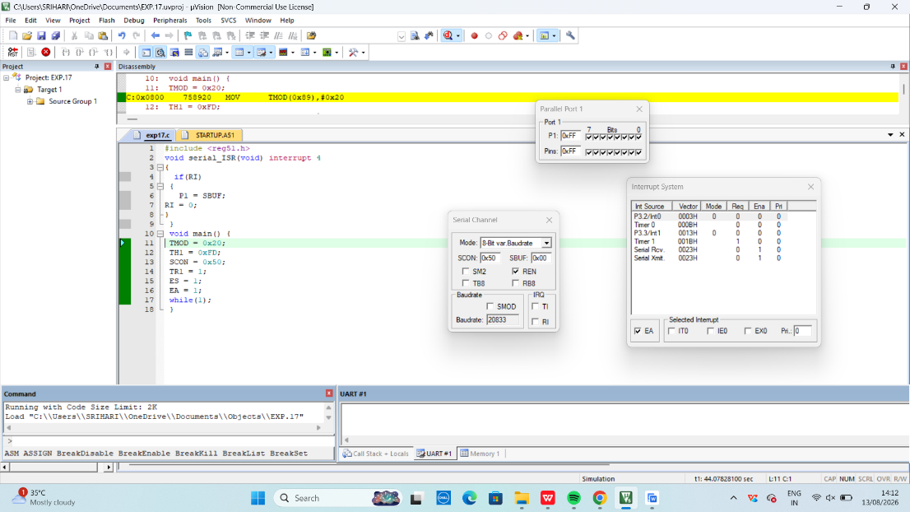
After interruption:

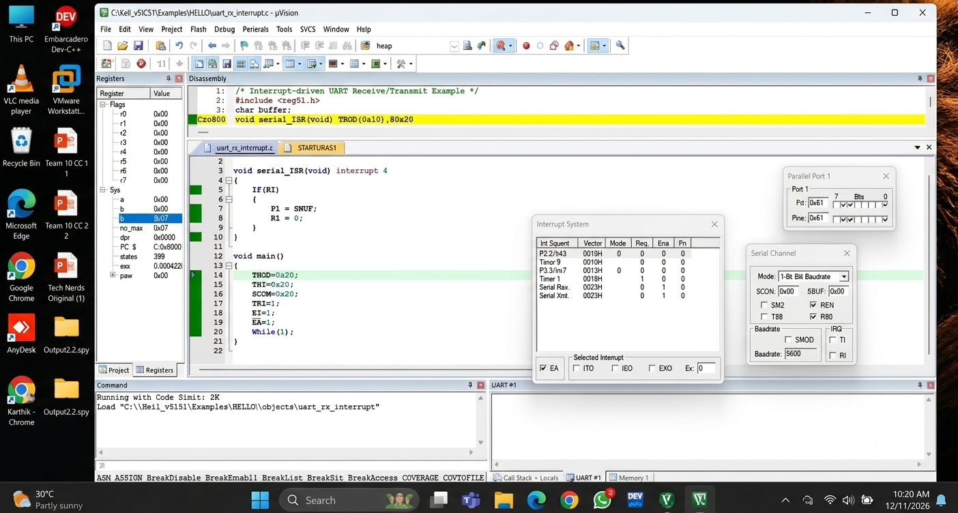

RESULT :
Thus, the serial interrupt using UART was successfully implemented and verified in Keil simulator. The interrupt was triggered upon keyboard input and serviced correctly using an Interrupt Service Routine.

